genetic algorithm and support vector machine based clustering

Chapter 1
INTRODUCTION
1.1 Introduction
Advancement in sensing and digital storage technologies and their dramatic growth within the applications starting from marketing research to scientific knowledge searching have formed a number of elevated quantities and elevated dimensional data sets. Mainly of the information become in electronic media have unfair the incident of cost-effective mechanisms for information recovery and usual tool of data processing for efficient categorization and group of elevated dimensional information. Furthermore to the here, the exponential increase of elevated dimensional knowledge requirements higher method to manually recognize procedure and review information. DM may be a technique of extract before unknown, potentially helpful and ultimately understandable information from the elevated number of information. Information processing system may be usually classified keen on 2 main modules. Information bunch may be a process of feature the usual groupings that exists in an very given information set, particular the substance within the identical bunch are extra similar and also the objects in numerous group are less similar (in substitute words, different).
It’s be regard as as a very important tool in numerous applications like pattern recognition, image process, data processing, remote sensing, statistics, etc. [1].Clustering is a system of information removal. It is an unsupervised learns system, which do not relies on predefined model and output classes. The input objects are just classified based on some observed criteria, which may not be predefined. The process of clustering is collecting a set of entities within a set of put out of joint group, known as group so that the items in the similar cluster have elevated relationship, but are extremely different with objects in further clusters. This system is utilized in lots of domains, for instance human science (environmental science, zoology etc.), health sciences (psychoanalysis, pathology etc.), public sciences (sociology, archaeology etc.), soil sciences (geography, geology etc.), and engineering [2]. Figure1.1 explains the system of clustering with four necessary phases:

Feature selection: This part selects distinctive characteristics from a collection of contenders whereas feature extraction employs some changes to provide useful and new characteristics from the distinctive ones. each are very vital to the success of cluster functions. sleek selection of characteristics might deeply shrink the employment and modify the succeeding style method.
Clustering rule selection: This part is usually incorporated with the selection of the same proximity determination and also the building of a principle performs. Patterns are clustered per whether or not they are kind of like one another. Clearly, the proximity determination straight influences the arrangement of the ensuing clusters. around all cluster algorithms are expressly or implicitly connected to some definition of proximity determination. many algorithms however work straight on the proximity matrix. Once a proximity determination is chosen, the building of a cluster principle perform creates the partition of clusters an optimization bother, that is well represented mathematically, and has made solutions within the literature [3].
Cluster validation: Group justification refers to trial that significance the outcome of cluster examination in an extremely quantitative and point approach. A clump structure is "valid" if it's "unusual" in some sense. Given an information set, every clump rule might continuously generate a division, regardless of whether or not the structure exists or not. Moreover, completely different approaches typically result in different clusters; and even for identical rule, parameter identification or the presentation order of input patterns might have an effect on the ultimate results. Therefore, effective analysis standards and criteria are vital to supply the purchasers with a degree of confidence for the clump results derived from the utilized algorithms. These assessments ought to be objective and don't have any preferences to any rule. Also, they ought to be valuable for responsive queries like what number clusters are hidden within the information, whether or not the clusters obtained are substantive or simply an artifact of the algorithms, or why we elect some rule rather than another.
Results interpretation: The last word goal of clump is to supply purchasers with substantive insights from the initial information, in order that they might effectively solve the troubles encountered. Specialists within the significant field understand the information partition. Additional analyzes, even experiments, is also needed to ensure the reliableness of extracted data. Cluster analysis isn't a one-shot method. In several circumstances, it wants a series of trials and repetitions. Moreover, there are not any universal and effective criteria to guide the choice of options and clump schemes. Validation criteria offer some insights on the standard of clump solutions. However even a way to select the acceptable criterion remains a trouble requiring additional efforts additional efforts.
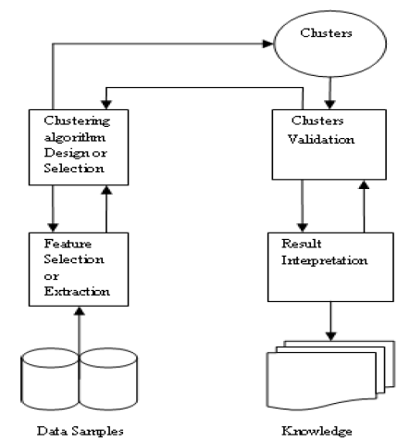
Figure1.1 Process of Clustering

1.2 Clustering
Clustering may be a selection of unsupervised learns not supervised learning like Classification. In group system, substance of the information set are off the record into group, in such the method that groups are very fully completely different from each other and additionally the objects at intervals constant group or bunch are very constant one another.
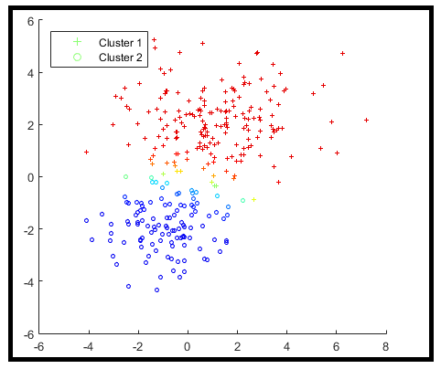
Figure1.2 Clustering
Not similar to categorization, during that predefined set of classes are given, but in group here are not any definite set of module which suggests that succeeding clusters do not appear to be known before the implementation of group algorithmic imperative. Throughout this these group are take out from the information set by collection the objects in group it. data processing involved predictive data analysis involves entirely completely dissimilar point of learning, similar to (i) supervised type learning used only labeled data (ii) unsupervised type clustering learning used only unlabeled data (iii) semi-supervised types learning as a cluster could also be tough disadvantage than classification. Types of entirely totally different data learning [4].
1.3 Learning Methods
Learning may be a basic capability of neural networks. Learning rules are algorithms for locating appropriate weights W and/or different network parameters. Learning of a NN is often viewed as a nonlinear optimization drawback for locating a group of network parameters that minimize the value perform for given examples. This type of parameter estimation is additionally known as a learning or training algorithmic program. It is networks are typically trained by epoch. an epoch may be a complete run once for examples square measure given to the system and are process victimization the training algorithmic program just one occasion. once learn, a NN represents a fancy connection and process the power for generalization. to manage a learning method, a criterion is outlined to determine the time for terminating the method. The quality of an algorithmic program is sometimes denoted as O(m), indicating that the order of variety of floating-point operations is m. Learning strategies are conventionally divided into supervised, unattended, and reinforcement learning; these schemes are illustrated in Fig. 1.3. xp and yp are the input and output of the pth pattern within the coaching set, ˆyp is that the NN production for the pth input, and E is a mistake perform. From a applied math viewpoint, unattended learning learns the pdf of the training set, p(x), whereas supervised learn learns regarding the pdf of p( y|x). supervised learning is wide utilized in classification, approximation, control, modeling and identification, signal process, and optimization. Unattended learning schemes are primarily used for agglomeration, vector division, feature extraction, signal secret writing, and information analysis. Reinforcement learning is sometimes utilized in management and AI. In distinction, induction is reasoning from discovered training cases to general rules that are then applied to the take a look at cases. Machine learning are inductive learning and transductive learning. Inductive learning pursues the quality goal in machine learning that is to accurately classify the complete input area. In distinction, transductive learning centered.
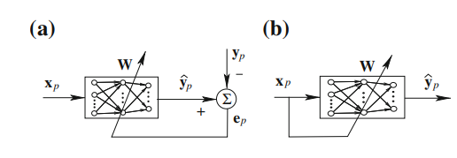
Figure 1.3 learning methods two types supervised learning and unsupervised learning
Going on a distinct aim set of not level information, the aim human being to make the particular aim set. Multiple job learning advances the generality show of beginner by investment the domain-specific data contained within the related tasks. Multiple connected tasks are learned at the same time using a shared illustration. In fact, the training signals for further tasks function AN inductive bias. So as to be told correct models for rare cases, it's fascinating to use information and data from similar cases; this can be referred to as transfer learning. Transfer learning may be a general technique for rushing up learning. It exploits the insight that generalization might occur not only among tasks, however additionally across tasks. The core plan of transfer is that have gained in learning to perform one supply task will facilitate improve learning performance in a very connected, however completely different, target task. modify knowledge is linked in strength to case-based and analogical learning. A theoretical Analysis supported an empirical Bayes perspective exhibits that the quantity of labelled examples needed for learning with transfer is usually considerably smaller than that needed for learning every target severally.

1.3.1 Supervised Learning
During this training data it contributes each the input and in addition the specified results. These strategies are quick and correct In supervised learning collectively observed as direct processing the variables below Investigation are divided t into 2 groups: informative variables and one (or more) dependent variables. The aim of this analysis is to specify a relation between the quantity and instructive variables. The values of the quantity ought to be notable for a sufficiently huge a neighborhood of the records set to continue with directed processing techniques. the proper results are known and are given in inputs to the model throughout the educational technique. supervised models are neural network, several layers Perception, call trees. supervised learning adjusts network parameters by a right away comparison between the particular network output and also the desired output. supervised learning could be a closed-loop feedback system, wherever the error is that the feedback signal. The error live, that shows the distinction between the network output and also the output from the coaching samples, is used to guide the educational method. The error live is sometimes outlined by the represent square error (MSE).where N is that the range of pattern pairs within the sample set, yp is that the output a part of the pth pattern try, and ˆyp is that the network output cherish the pattern try p. The error E is calculated anew when every epoch. the educational method is terminated once E is sufficiently little. To reduce Error in the direction of nil and a rise decline process be sometimes applied. The gradient-descent methodology continually converges to a neighborhood minimum during a neighborhood of the initial answer of network parameters. The LMS and BP algorithms are 2 most well-liked gradient-descent primarily based algorithms. Second-order strategies are supported the computation of the Wellington matrix. Multiple-instance learning could be a difference of supervise learn. In several request learn for the examples are luggage of instances, and also the bag label could be a perform of the make of its case in point. Normally perform is that the mathematician or. A incorporated conjectural study for numerous case in point learn and a PAC knowledge method are introduce in. reasoning begin from a origin to work out the consequence or effects. Generalization permits United States of America to deduce doable causes from the consequence. The inductive learning could be a special category of the supervised learning techniques, wherever given a group of pairs, we confirm a hypothesis h(xi) specified h(xi) ≈ f (xi), ∀i. In inductive learning, given several positive and negative instances of a haul the learner should type a thought that supports most of the positive however no negative instances. This needs variety of training instances to make a thought in inductive learning. in contrast to this, no literal learning is accomplished from one example; as an example, given a training instance of plural of plant as fungi, one will confirm the plural of bacilus: Bacillus -> bacilli.
1.3.2 Unsupervised Learning
The representation is not continuing with the proper results throughout the working out. It need to be used to cluster the laptop go into classes on the support of their chance properties only. In unattended learning, all the variables area unit treated in same technique, there is not any distinction to the name purposeless method, and still there is some target to understand. This target may well be as knowledge reduction as general or any specific like cluster. The differentiation between unattended learning and supervised learning is that identical that distinguishes discriminate analysis from cluster analysis. Supervised learning desires, target variable have to be compelled to be compelled to be written that an enough vary of its values are given. Unattended teach sometimes either the aim variable has between dependent and informative variables. However, in mere been recorded for too little type of cases or the target variable is unknown .Unsupervised models are non identical types of cluster, amplitude and standardization, k-means, self organizing maps. Unsupervised learning involves no target values. It tries to automotive vehicle associate info from the inputs with AN intrinsic reduction of information spatial property or total quantity of computer file. Unsupervised learning is alone supported association in the middle of the computer file, and is employed to search out the numerous patterns or options within the computer file while not the assistance of a lecturer. Unsupervised learning is especially appropriate for biological learning therein it doesn't suppose a lecturer and it uses intuitive primitives like neural competition and cooperation. A criterion is required to terminate the educational method. while not a stopping criterion, a learning method continues even once a pattern, that doesn't belong to the training patterns set, is given to the network. The network is customized consistent with a perpetually ever-changing atmosphere. Hibbing and spirited learning, therefore the some are the 3 famous unsupervised discover come close to. Usually speaking, unsupervised learning is slow to settle into stable conditions. In Hebbian learning, learning may be a strictly native development, involving only 2 neurons and a conjugation. The conjunction weight modification is proportional to the association among the before and after synaptic signals. Several NN for PCA and associative memory are supported Hebbian learning. In competitive learning, the production neurons of NN for the proper to retort. The som is additionally supported ready for action learning. spirited learning is directly linked with bunch. The Boltzmann machine uses a random training technique referred to as simulated hardening, which might be treated as a special kind of unsupervised learning supported the inherent property of a physical system.
1.3.3 Semi-Supervised Learning
Semi-supervised learning a while in addition referred to as hybrid setting, involves partial varieties of absolutely entirely totally different levels of learning knowledge labeled and unlabeled knowledge sets for understanding the hidden behavior of the info sets. Cluster is a harder and difficult disadvantage than classification. In several machine learning applications, like bioinformatics, internet and text mining, text categorization, information promoting, spam detection, face recognition, and video indexing, easy amounts of unlabeled information is cheaply and automatically collected. However, manual labeling is commonly slow, expensive, and fallible. Once only a little range of labeled samples are offered, unlabeled samples can be accustomed forestall the performance degradation attributable to over fitting. The goal of semi-supervised learning is to use an oversized assortment of unlabeled information put together with some labeled examples for up generalization performance. Some semi-supervised learning strategies are supported some assumptions that relate the probability P(x) to the conditional giving out P(Y = 1|X = x). Semi supervised learning is expounded to the matter of transductive learning. Two typical semi-supervised learning approaches are learning with the bunch statement and learning with the various statements. The cluster assumption needs that information among constant cluster are additional doubtless to own constant label. the foremost outstanding example is that the transductive SVM . Universum knowledge are given a collection of unlabeled examples and don't belong to either category of the classification drawback of interest. Contradiction happens once 2 functions within the same equivalence category have totally different signed outputs on a sample from the Universe. Universe learning is conceptually altogether totally different from semi-supervised learning or transduction, as a results of the Universum data is not from constant distribution as a result of the tagged training info. Universum learning implements a trade-off between explaining training samples (using big margin hyper planes) and increasing the number of contradictions (on the Universe). In active learning, or supposed pool-based active learning, the labels of information points are initially hidden, and so the learner ought to acquire of each label he has to be disclosed. The goal of active learning is to actively opt for the foremost informative examples for manual labeling in these learning tasks, that is, designing input signals for optimum generalization. supported conditional expectation of the generalization error, a pool-based active learning methodology effectively copes with model misspecification by constant training samples in line with their importance. Reinforcement learning is also thought-about a sort of active learning. At now, an issue mechanism proactively asks for the labels of variety of the unlabeled data examples of things within which active learning may be used are internet looking out, email filtering, and relevancy feedback for a info or web site. the primary 2 examples involve induction. aim is to make a classifier that works well on unseen future instances. The third scenario is an example of transduction. Beginner presentation is charge on the outstanding instance within the data instead of a completely independent take a look at set. The query-by-committee rule is a lively learning rule for classification that uses a previous distribution over hypotheses. During this rule, the learner observes a stream of unlabeled info and makes spot picks relating to whether or not or not or to not hearth each point’s label. If the data is drawn uniformly from the surface of the unit sphere in Rd , and thus the hidden labels correspond completely to an even (i.e.,through the origin) linear setup from this same distribution, then it's possible to attain generalization error once seeing O((d/)log(1/)) points and requesting simply O(d log(1/)) labels: AN exponential improvement over the quality O(d/) sample quality of learning linear separators in AN extremely supervised setting. The query-by-committee rule involves sampling from intermediate version spaces; the quality of the update step scales polynomials with the quantity of updates performed. AN data-based approach for active information alternative is given. In, a two-stage sampling theme for reducing each the bias and variance is given, and supported it, 2 active learning strategies are given. In an exceedingly framework for batch mode active learning, variety of informative examples square measure elite for manual labeling in every iteration. The key feature is to scale back the redundancy among the chosen examples specified every example provides distinctive info for model change. The set of unlabelled examples that may with efficiency cut back the Fisher info of the classification model is chosen [5].
1.4 Types of Clusters
Well-separated clusters: cluster is also a group of functions such any purpose throughout a cluster is nearer (or more similar) to each wholly completely different purpose among the cluster than to any purpose not at intervals the cluster. A cluster may even be a settle of functions thus any purpose really} terribly cluster is nearest (or ample similar) to every totally wholly completely different purpose at intervals the cluster as differentiate to the alternative purpose that is not at intervals the cluster.
Center-based clusters: once associate object is more getting ready to or nearly rather like the cluster throughout that it resides then the choice clusters then it's stated as center-based cluster. In centroid-based bunch, clusters are delineate by a central vector, that cannot primarily be a member of the data set. once the amount of clusters is mounted to k, k-means bunch offers a correct definition as associate optimisation problem: understand the k cluster centers and assign the objects to the nearest cluster center, such that the sq. distances from the cluster are reduced. The optimisation downside itself is assumed to be NP-hard, and then the common approach is to appear only for approximate solutions. a awfully commonplace approximate technique is Lloyd's formula, usually merely same as "k-means formula" (although another algorithmic program introduced this name). it'll however solely understand a section optimum, and is commonly run multiple times with wholly completely different random initializations. Variations of k-means usually embody such optimizations as choosing the foremost effective of multiple runs, but to boot limiting the centroids to members of the data set (k-medoids), choosing medians (k-medians clustering), choosing the initial centers less haphazardly (k-means++) or allowing a fuzzy cluster assignment (fuzzy c-means).Most k-means-type algorithms want the amount of clusters - k - to be arranged go into advance, that's thought-about to be one among the most important drawbacks of those algorithms. What is more, the algorithms like clusters of roughly similar size, as they'll continually assign associate object to the nearest center of mass. generally outcome in incorrectly section limits of clusters (formula optimizes cluster centers, not bunch limitations).K-means options a spread of attention-grabbing theoretical properties. First, it partitions the data space into a structure cited as a Voronoi diagram. Second, it's conceptually close to nearest neighbor classification, and in and of itself is modish in machine learning. Third, it's seen as a variation of model based totally bunch, and Lloyd's formula as a variation of the Expectation-maximization formula for this model mentioned below.
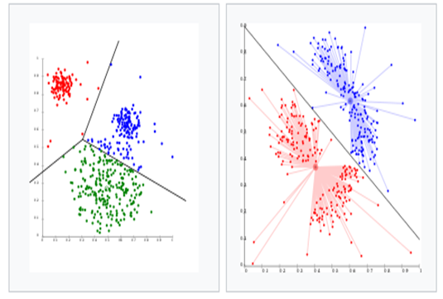
Figure 1.4 (a) K-means separates information into Voronoi-cells, that assumes equal-sized clusters (not adequate here), (b) K-means cannot represent density-based group
Shared Property (Conceptual Clusters): it's the fairly clusters that share some commo property or represent a specific plan [6].
Contiguous clusters (Nearest neighbor or Transitive): cluster would be a group of functions such some extent throughout a cluster is nearer (or additional similar) to 1 or additional whole completely different functions among the cluster than to any purpose not among the cluster. Connectivity-based clump, to boot mentioned as class-conscious clump, relies on the core arrange of objects being plenty of related to close to objects than to things farther away. These algorithms connect "objects" to make "clusters" supported their distance. A cluster is painted principally by the foremost distance needed to connect elements of the cluster. uncommon distances in cluster and a few completely different clusters will different sort, which can be painted employing a dendrogram that explains where the common name "hierarchical clustering" comes from: these algorithms do not provide one partitioning of the knowledge set, but instead provide an intensive hierarchy of clusters that merge with each other at certain distances. In an passing dendrogram, the axis marks the area at that the clusters merge, whereas the objects are placed on the axis such the clusters don't mix. Connectivity-based clump could also be whole families of the way that disagree by the tactic distances are computed. Existing alternative of distance functions, the user to boot needs to select the linkage criterion (since a cluster consists of multiple objects, there square measure multiple candidates to cipher the distance) to use. Common alternatives are mentioned as single-linkage clump (the minimum of object distances), complete linkage clump (the most of object distances) or UPGMA (Unweighted strive cluster technique with Arithmetic Mean", collectively mentioned as average linkage clustering). class-conscious bunch is agglomerate or discordant.
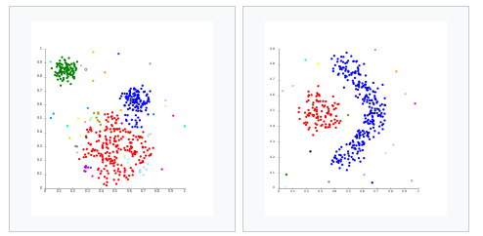
Figure 1.5 Linkage clustering
Density-based clusters: cluster is a dense region of points that is separated by low-density regions, from utterly completely different regions of high density. This type of cluster used on condition that the clusters unit irregular or tangled and once noise and outliers are present.
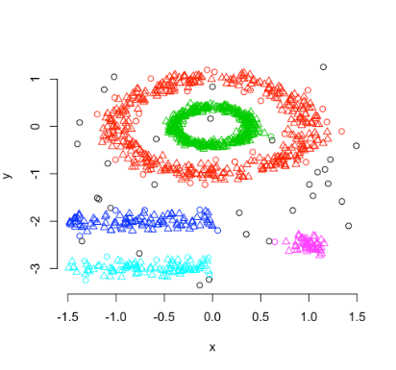
Figure 1.6 density-based clustering
1.5 Problem Statements
Dataset analysis drawback in field of the {information} mining in agglomeration algorithmic program using k-means cluster algorithmic program however cluster algorithmic program drawback aren't any actual data in giant dataset and additionally error full information then description and there are many concepts of however a cluster will be outlined. K-means clustering however it suffers from performance issues in several ara; processing is additionally important challenges are here large amount of information. Machine learning techniques are used for determination varied problems in modern science, medicine, finance, engineering, Image analysis, Bioinformatics, Earthquake studies, Insurance and lots of different areas. The k-means methodology may be a common approach to cluster, however drawback that the generation of right vary of cluster and different is content validation disadvantage. Cluster in any information set are going to be achieved by minimizing the intra-cluster distinction and increasing the inter-cluster distinction. Throughout this thesis our main interest is to reduce these difficulty by using improve cluster algorithmic program supported K-means cluster.
  - Objectives
Discover structures and patterns in high-dimensional information. group information with similar patterns along. The objectives of this analysis work are:
- It is the most important flat minis in clustering algorithm.
- Its objective is to minimize the average distance.
- It is provide a single platform to place the clusters of similar news headlines
- It is decrease the difficulty of record analysis. This reduces the complexity and facilitates interpretation
- Reliable data and Authentication data
1.8 Organization of the Dissertation
This dissertation consists of six chapters. Include this chapter.
Chapter 1 Introduction
This chapter introduces some basic concepts, the problems to address, and the thesis statement and provides the motivation and justification for the work described in this dissertation
Chapter 2 Literature Survey
This chapter provides a brief description of Watermarking used in Image. It also provides the details of k-mean clustering method.
Chapter 3 Clustering Background
This chapter provides details of Clustering Background
Chapter 4 Proposed Work
This chapter provides details of Proposed Work.
Chapter 5 Simulation and Result analysis
This chapter provides the details of Simulation Environment and Result performance evaluation.
Chapter 6 Conclusion and Future Work
This chapter includes conclusion and future scope of the dissertation.

Chapter 2
Literature Survey

2.1 Related Work
AnkitaVimal et al [7]. A short study of varied distances measures and their impact on totally different cluster algorithms is applied during this article. With the assistance of k-mean matrix partitioning and dominance primarily based cluster algorithms; euclidian distance live and different four distance live were studied to research their performance by accuracy of varied techniques exploitation artificial datasets. Real-world information sets of cricket and artificial datasets from Syndical software system were used for cluster analysis. during this study it's found that the euclidian distance live performs higher than the opposite measures. Distance live plays a very important role in clump information points. selecting the correct distance live for a given dataset could be a non-trivial drawback. during this paper, we tend to study varied distance measures and their impact on totally different cluster techniques. additionally to the quality geometrician distance, we tend to use Bit-Vector primarily based, Comparative cluster primarily based, Huffman code primarily based and Dominance based distance measures. we tend to cluster each artificial datasets and one real world dataset exploitation the on top of distance measures by using k-means, matrix partitioning and dominance primarily based cluster algorithms. They analyses the results of our study using a real world dataset of cricket and compare the accuracy of varied techniques exploitation artificial datasets.
Li et al. [8] projected eliminating the problems of the standard k-means cluster rule for agglomeration giant information. The k-means bunch rule, being with efficiency able to handle the increasing size of information brings with it an increased time complexness. Authors projected optimizing k-means per the Hadoop tool cloud computing platform and Map scale back Framework that allows distributed and processing of data. The rule starts by format of the cluster centers followed by partitioning the dataset into equally sized very little data blocks for data processing. The blocks are then exposed to the Map and reduce tasks that run until the required agglomeration results area unit achieved. improvement of the k-means rule is additionally worn out terms of format of cluster centers that otherwise cause instability in agglomeration results. Aiming at the defects of ancient K-means agglomeration rule for large information, this paper provides K-means agglomeration mining improvement rule supported huge information, shows a map cut back code design that is appropriate for big processing mechanism, provides Associate in Nursing improved technique for choosing initial agglomeration centers and puts forward a K-means rule improvement supported Map cut back model. The improved rule is applied to the coal quality analysis, the result shows that compared with ancient algorithms, the improvement rule improves the efficiency of the rule clearly, and also the accuracy is additionally increased.
A k Patidar et al. [9] .used four customary similarity live functions like euclidian, Cosine, Jaccard and Person correlation operate in SNN agglomeration rule on an artificial dataset, KDD Cup'99, Mushroom information set and a few every which way generated information. In SNN technique usually information should be clean so as to search out desired cluster. Here, they're inserting un-clustered information to desired core cluster discovered by SNN rule. Ultimately, they suggested in their studies that geometer live performed well in SNN rule adore different three measures. agglomeration is also a way of grouping data with analogous data content. In recent years, Density based agglomeration algorithms notably SNN cluster approach has gained top quality at intervals the sphere of data mining. It finds clusters of assorted size, density, and shape, at intervals the presence of giant amount of noise and outliers. SNN is wide used where big two-dimensional and dynamic databases are maintained. A typical agglomeration technique utilizes similarity operate for comparison varied data things. Previously, many similarity functions like geometer or Jaccard similarity measures are worked upon for the comparison purpose. throughout this paper, we've evaluated the impact of four entirely totally different similarity live functions upon Shared Nearest Neighbor (SNN) agglomeration approach and thus the results were compared later on. supported our analysis, we arrived on a conclusion that euclidian operate works best with SNN agglomeration approach in distinction to cosine, Jaccard and correlation distance measures operate.
Feldman et al [10] proposed exploitation coresets giant|of huge|of enormous} information rather than exploitation big information for bunch functions. Running the cluster rule on a corset helps in reducing the question time interval tho' satisfying the precise constraints and optimality definitions as utilized by the dataset. The proposal relaxes the data boundations of the previous algorithms of knowing the quantity of information points and therefore the dimensions beforehand and is restricted to taking them in increasing order for every new inserted value. exploitation the merge and cut back paradigms, the k-means, PCA and projected cluster are created into parallel streaming cluster algorithms. we prove that the add of the square euclidian distances from the n rows of associate degree n×d matrix A to any compact set that's spanned by k vectors in R d is approximated up to (1+ε)-factor, for an discretional tiny ε > zero, exploitation the O(k/ε2 )-rank approximation of A and a continuing. this suggests, for instance, that the best k-means cluster of the rows of A is (1+ε)- approximated by an best k-means cluster of their projection on the O(k/ε2 ) 1st right singular vectors (principle components) of A. A (j, k)-coreset for projective group might be present a tiny set of points that yields a (1 + ε)-approximation to the add of square distances from the n rows of A to any set of k affine subspaces, every of dimension at the most j. Our embedding yields (0, k)-coresets of size O(k) for handling k-means queries, (j, 1)-coresets of size O(j) for PCA queries, and (j, k)-coresets of size (log n) O(jk) for any j, k ≥ one and constant ε ∈ (0, 1/2). Previous coresets sometimes have a size that is linearly or perhaps exponentially dependent of d, that produces them useless once d ∼ n.
exploitation our coresets with the merge-and-reduce approach, they get embarrassingly parallel streaming algorithms for problems like k-means, PCA and projective cluster. These algorithms use update time per purpose and memory that is polynomial in log n and entirely linear in d. For price functions excluding sq. euclidean distances they advise a straightforward algorithmic coreset construction that produces coresets of size k 1/εO(1) for k-means and a special class of bregman divergences that is less obsessed on the properties of the sq. euclidean distance
Sadeghian A.H et al. [11]. information removal is one in every of the useful and effective information analysis techniques that modify the taking out of attractive formation and information from an oversized quantity of information. Agglomeration is a very important data processing information removal is single job that refers to the method of categorizing knowledge objects into cohesive teams known as clusters. There are several agglomeration approaches planned within the literature with completely different quality/complexity tradeoffs. it's accepted that no agglomeration methodology will sufficiently handle every kind of cluster structures and properties (e.g. shape, size, overlapping, and density). the thought of mixing completely different agglomeration results (cluster ensemble or agglomeration aggregation) emerged as an approach to beat the weakness of single algorithms and any improve their performances. during this paper, a unique consensus operate supported the idea of gravity is conferred that is termed “Gravitational Ensemble agglomeration (GEC)”. The planned methodology combines “weak” agglomeration algorithmic rules like the K-means algorithm victimization gravitative agglomeration ideas. The planned methodology is capable of the identification of true underlying clusters with impulsive shapes, sizes and densities. method experiments were conducted to envision the performance of the GEC approach victimization artificial and benchmark datasets. Undertaken experimental results illustrate the pliability and strength of the planned methodology, as compared to individual agglomerations created by accepted cluster algorithms, and compared to various ensemble combination methods.
Gehrke et al. [12] has delineate concerning processing applications and utterly alternative ways of cluster documents. the target of their work is to spot the bunch ability of the algorithms for identifying the clusters embedded in subspaces. This topological space contains high dimensional info and quality. HPSO (Hybrid Particle Swarm Optimization) may be a brand new and innovative cluster technique addressed throughout which mixes choices of partitional and stratified agglomeration techniques and well-tried to be very economical and powerful for taking part in graded cluster. It employs the swarm intelligence of ants in an exceedingly} very suburbanised surroundings.
ShiYao Liu et al. [13] researched similarity-based strategies of cluster. They adopted weights into those strategies so priorities will be assigned . Then they wear all this incorporation for group ensembleing with experiment on world information sets. in line with authors results are established to be suitable and beneficial than alternative approaches. during this paper, a replacement paradigm of cluster is planned, that is predicated on a replacement Binarization of accord Partition Matrix technique. This technique exploits the results of multiple cluster experiments over identical dataset to come up with one fuzzy accord partition. The planned tunable techniques to binarize this partition replicate the biological reality in this it permits some genes to be appointed to multiple clusters et al to not be assigned in any respect. The planned technique has the flexibility to indicate the relative tightness of the clusters, to come back up he relative tightness of the clusters, to come back again up with tight cluster or wide overlapping clusters, and to extract the special genes that endure the profiles of a couple of clusters at the same reason in time. A person-made periodic series dataset is analysed via this technique and moreover the numerical consequences display that the method has been in in displaying fully absolutely distinct horizons in series cluster
Malay K. Pakhira et al. [14].Modified K-means formula has been projected that solves the empty cluster drawback. This changed K-means formula had created effective result and experiments had verified this methodology higher than the standard bunch techniques.
Carl Meyer et al. [15]. They use a cluster ensemble to determine the quantity of clusters, k, during a cluster of information. A accord similarity matrix is made from the ensemble victimization multiple algorithms and a number of other values for k. A stochastic process is induced on the graph outlined by the accord matrix and also the Eigen values of the associated transition likelihood matrix are wont to verify the quantity of clusters. For noisy or high-dimensional information, AN repetitious technique is bestowed to refine this accord matrix in method that encourages a block-diagonal type. it's shown that the resulting accord matrix is mostly superior to existing similarity matrices for this sort of spectral analysis. Targeted ensemble downside by stating that choice of appropriate cluster ensemble technique for specific information in unsupervised manner becomes important due to inaccessibility of true data at hand before agglomeration. in line with authors accord affinity of cluster ensemble helps considerably improvement for ensemble resolution choice and even for partition choice.
Wang et al. [16]. He focuses in his paper on introducing some novel criteria for deciding the quantity of clusters. This new choice criterion measures the standard of clustering’s through their instability from sample to sample. Here the bunch instability is calculable through cross validation, and therefore the goal of the strategy is to reduce the instability. the information is split into 2 training sets and one validation set to imitate the definition of stability. Then, a distance based mostly bunch rule is applied on the self-determining and identically concentrated training sets and therefore the inconsistencies evaluated on the validation set. This system has be confirmed to be effective and strong on a range of simulated and real world examples.
Doreswamy et al. [17]. Organizing information into semantically additional significant is one among the basic modes of understanding and learning. Cluster analysis could be a formal study of strategies for understanding and rule for learning. K-mean bunch rule is one among the foremost basic and easy bunch algorithms.
once there's no previous data regarding the distribution of information sets, K-mean is that the initial selection for bunch with an initial variety of clusters. during this paper a completely unique distance metric known as design Specification (DS) distance live operate is integrated with K-mean bunch rule to enhance cluster accuracy. The K-means rule with projected distance live maximizes the cluster accuracy to 99.98%at P = one.525, that is decided through the repetitious procedure. The performance of design Specification (DS) distance live operate with K - mean rule is compared with the performances of alternative normal distance functions like geometer, square Euclidian, Town block and chebshew similarity measures deployed with k-mean rule. The projected method is evaluated at the engineering materials data. The experiments on cluster analysis and additionally the outlier identity display that these is a first rate development in the performance of the projected system.

Chapter 3
CLUSTERING BACKGROUND

3.1 Overview
Group is bunch put in information sets keen on associate sets, referred to as 'clusters' at intervals that the weather is somewhat similar. In general, bunch is an unsupervised find out job as little or no or no previous data is given with the exception of the computer file sets. The tasks are utilized in several fields and so varied bunch algorithms are developed. Cluster is outlined as dividing input data sets referred to as `clusters'. As a unsupervised learning tasks, bunch tasks are exploited in several fields as well as image/video process, machine learning, data processing, organic chemistry and bioinformatics. depending on the information properties or the aim of bunch, differing kinds of bunch algorithms are developed, such as, partitional, hierarchical , graph-based bunch etc. Most of the bunch task needs repetitive procedures to search out regionally or globally best solutions from high-dimensional knowledge sets. Additionally, terribly rarely real-life information present a novel bunch resolution and it's conjointly onerous to interpret the `cluster' representations. Therefore, it needs a lot of experimentation with completely different completely different} algorithms or with different options of an equivalent information set. Hence, they're procedurally expensive and saving computational complexness may be a vital issue for the bunch algorithms. Therefore, the parallelization of bunch algorithms is extremely practical approach, and therefore the parallel strategies are going to be varied for various algorithms. during this paper, they initial classify a number of existing bunch algorithms and observe the properties. The literatures regarding bunch algorithms classify several bunch algorithms into completely different purpose of views. principally following the categorization .clustering algorithms will be classified into 6 kinds of algorithms: partitional, hierarchical , organic process, dense-based, model-based and graph-based cluster algorithms [17].

3.2 General Information of Clustering Analysis
Defined the cluster analysis because the organization of a group of patterns into clusters supported similarity. the problem lies within the definition and therefore the scope of `cluster' within the information set. the definitions of a cluster, that are introduced in: 1) a group may be a set of similar items and consequently the objects in numerous clusters shouldn't be similar; 2) a cluster is that the set of factors which can be collective within the trying out putting such place among 2 points in a totally cluster is a smaller quantity than the distance among the factors of alternative clusters; 3) clusters is densely related regions in a very multi-dimensional space separated by means of loosely related factors. supported the purposed of the appliance, totally different completely different} thought of clusters and different cluster algorithms is applied. the primary idea focuses on the minimum intra-cluster, whereas the second considers between-clusters and intra-clusters at identical time. Graph-based and dense-based cluster algorithms square measure developed principally supported the last thought [18].

3.2.1 Distinguishing features of Clustering Analysis
Clustering evaluation is prominent with opportunity evaluation within the following criterion. First, clump evaluation is unsupervised category. In comparison to supervised category whose purpose is to assign an records input into one in every of the categories supported the category found out with tagged education information, unsupervised type is given unlabeled information. The goal is to separate or partition a group of unlabeled statistics sets into many clusters supported the summary or hidden houses of the pc document setsSecond, clump analysis is completely different from unsupervised prophetical learning. unsupervised prophetical learning includes vector quantization, chance density operate estimation and entropy maximization, and these offer an correct characterization of unobserved samples generated from identical chance distribution. within the alternative hand, bunch study is unsupervised `non predictive' learning that divides the info sets into a lot of sub part sets on their individual capacity, that isn't supported the 'trained characterization [19].

3.2.2 Clustering Analysis Components
A bunch task desires many essential steps as mentioned in and people steps are emphasized within the paper similarly. Jain et al represented the steps because the go after: 1) sample illustration, 2) measurements applicable to the information domain, 3) bunch or grouping, 4) information thought and 5) evaluation of production. Outline show the satage with a response pathway wherever the cluster output will modification the feature selection/extraction method reciprocally. First, the patterns are described in how through feature choice or feature extraction method that identifies the foremost important options from the first patterns or produces new outstanding options severally. The second step is to outline an acceptable metric for information to cluster and design a bunch algorithmic rule. the best example of measurements is euclidian distance. during this step, an objective perform and any constraints are outlined. The grouping step, because the next step, is implemented with totally different bunch algorithms. Totally different bunch algorithms and their relationships are represented more in section three. The fourth step, information abstraction method refers to the method Of extracting a compact instance of an information set. Typically inside the bunch assignment, the compact example may be a set of centers or prototypes of each cluster. The remaining step is that the analysis of bunch outcomes. Any cluster method can produce clusters, in spite of the truth that the information sets do not encompass any clusters in nature. Therefore, the assessment of clusters gives many aspects: cluster tendency, which assesses the data domain; cluster validity, this is that the analysis of a group output. 3 varieties of validation, inner, external and relative examination exist. Internal validity is to determine if the structure is accurate for the information, external validity is to match the recovered shape to an a priori shape, and additionally the relative validity is to in shape 2 systems [8].

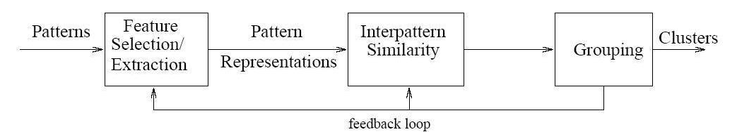
Figure 3.1 Clustering Procedure with a Feedback Pathway

existing method illustrated the procedure of agglomeration task equally because the followings: 1) Feature choice or extraction, 2) agglomeration algorithmic rule design or choice, 3) bunch confirmation and 4) outcome study. As are within the paper, the four steps of have a feedback pathway, and that they are closely associated with one another and have an effect on the calculated clusters as represented in.
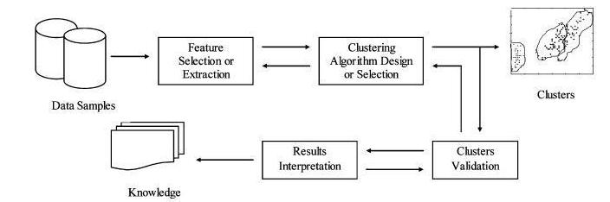

Figure 3.2 Clustering Procedures with a Feedback Pathway

Given an information samples, cluster tasks initial perform a feature choice or feature extraction as within the beginning in. Then the second one and therefore the 0.33 steps of are blended because the second one step of `clustering algorithmic software layout or section' for the duration of this paper. The selected cluster algorithmic application can carry out the cluster undertaking to get a group of clusters and therefore the statistics is abstracted as a compact illustration, a collection of cluster prototypes. Then existing method describes the cluster validation step because the following step. Previously in , the step is enclosed inside the closing step of `evaluation of output'. The look at of cluster validation includes an efficient evaluation commonplace, and 3 testing criteria; inner, outside and relative cluster validity. 'Results interpretation' step is that the method which provides users significant interpretation of knowledge sets, that sometimes involves the specialists of original information sets. This step is additionally the primary step within the feedback path [20].

3.2.3 Desirable Features of Clustering Analysis

In trendy, there are a set of applicable options for a cluster, represented via andreopoulos due to the fact the followings.

Scalability: the temporal and spatial complexness should not explode on large records units.

Robustness: the approach should note outliers inside the records set.

Order insensitivity: the algorithmic rule shouldn't be touchy to the ordering of the enter report.

Minimum person-distinctive enter: the amount of consumer-designated parameters ought to be reduced.

Mixed records kind: information is defined as numbers or binary attributes or blended of them.

Arbitrary-formed clusters: the clusters are fashioned arbitrary.

Point share admissibility: duplicating information set and re-clustering venture should not modification the cluster consequences. Completely specific agglomeration algorithms manufacture unique outcomes with one-of-a-kind options. Consequently, a agglomeration algorithmic rule need to be selected supported the applications due to the fact the applicable alternatives are utility based.

3.2.4 Challenges in Clustering Analysis

Clustering analysis may be a difficult task. There’s no normal answer that may answer the queries like, the way to normalize the information what’s the suitable similarity measure to the information. The way to incorporate the information within the data domain. The way to cluster an outsized data set efficiently thus we are able to list a number of challenges of cluster algorithms. First most of the cluster algorithms would really like style of repetitions or trials. And no prevalent manual of function choice or extraction
Additionally, no universal validation criteria for the normal of the results and no standard answer exist. Thus numerous cluster algorithms are developed for overcoming those drawbacks and that we in brief review variety of cluster algorithms within the next section [20].
3.3 Numerous Approaches to Data Cluster and Applications
Before we discuss parallel cluster rule, we review numerous sequent cluster algorithms and extend the idea supported an equivalent categorization.
3.3.1 Taxonomy of cluster Algorithms
Various information cluster algorithms are classified into numerous ways in which as we are able to see within the papers. Provided the taxonomy of the cluster algorithms for the duration of a statistics shape as represented in determine. Most of the cluster algorithms are divided into one in each of the 2 techniques; hierarchical and partitioning cluster algorithms.
The classification of cluster algorithms is predicated on the many cross-cutting aspects of as represented.
•Agglomerative vs. Divisive: It refers to recursive constitution and process, given that an bunch approach may be a bottom up construction whereas divisive is peak downhill come close to. Generally this side distinguishes the ranked cluster algorithms.
•Monothetic vs. Polythetic: It refers to the various uses of options within the method, either successive or synchronic. Whereas most of algorithms are polythetic, Ander berg reported an easy monopthetic formula in [21].
•Hard vs. Fuzzy: This side refers to the membership of the info. a tough cluster assigns one information to only 1 cluster whereas a fuzzy clump assigns one to multiple clusters. a number of applications in reality need the fuzziness.

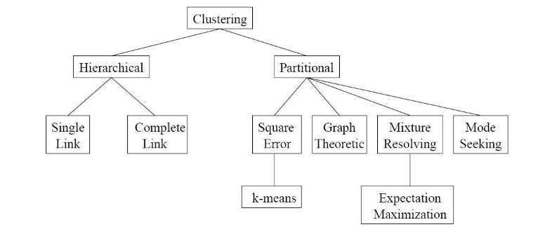

Figure 3.3 Taxonomy of Clustering Approaches

•Deterministic vs. Stochastic: it's associated with the optimum techniques the cluster formula is exploitation. Most of partitioning clusters method use either a settled objective operate or a arbitrary search system for optimization.

•Incremental vs. Non-incremental: The formula wherever the scale of information are often increased is taken into account as progressive otherwise non-incremental.

3.3.2 Various Clustering Algorithms

Because of the various aspects of the cluster algorithms, categorization of existing cluster algorithms also are varied as we are able to see within the survey papers of cluster algorithms. during this paper, we tend to are largely following the classification of Andreopoulos because it is most up-to-date survey paper, and therefore the classification is nicely structured.

Andreopoulos divided the complete cluster algorithms into vi categories: Partitioning, hierarchal, grid-based, density-based, model-based and graph-based cluster algorithms. we tend to omit the discussion of grid-based algorithmic rule. Instead, we tend to add another class, biological process cluster algorithms, described. Note that this categorization may be a flexible categorization as a quantity of them will belong to many categorizes.

3.3.2.1 Partitioning Clustering Algorithms
Partitioning agglomeration ways are helpful for the applications wherever a set variety of clusters are needed and Andreopoulos additional separated it into mathematical ways and distinct strategies. Partitioning algorithms assign {a variety|variety} of information into k number of clusters. K-means rule and Farthest initial Traversal k-center (FFT) rule [23], K-medoids [22] or PAM (partition approximately Medoids), CL.ARA (Clustering massive Applications), CLARANS (Clustering giant Applications based mostly Upon randomised Search) and Fuzzy K-means[24]. In k-means rule, the amount of clusters k is that the user-specified parameter. With k variety of initial mean vectors, k-means rule iteratively assigns the objects into one in every of cluster whose center is that the nighest with it. the method continues till there's no different re-assignment or it depends on the user-specified threshold. regardless of of its difficulty and straightforward implementation, k-means has many drawbacks additionally. for example, there's no normal. rather than many runs with random decisions, Bradley and Fayyad presents a refinement k-means algorithms, wherever many preliminary k-means results will give the original dot for subsequent run of the rule, so it ends up in an improved local minimum points. Likas et al. prompt a world k-means rule which incorporates a collection of k-means processes with varied variety of clusters. They additionally prompt the extension of the parallel implementation of the rule. rather than given k, Ball and Hall projected the technique of ISODATA wherever the quantity of cluster k is calculable with merging and rending processes. however it additionally involves another user-specified threshold for those processes. ancient k-means rule takes O(Nkd) at every iteration wherever N is that the variety of information and d is dimension. Kanungo et al. given associate economical implementation of Lloyd's k-means rule that is that the filtering rule mistreatment kd-tree organisation. In detail, operation of k d-structure was projected. The rule begin by accumulate all information points in a very k d-tree, and continue a set of applicant centers. The candidate centers area unit filtered as they're passed to its youngsters. Because the kd-tree is made supported the information points, it doesn't have to be compelled to be updated at every iteration, that saves the time overall.
Ng and Han developed a brand new agglomeration technique known as CLARANS that is dynamic version of CLARA applicable for oversized information set by sampling inputs, for the applying to special databases. CLARANS relies on randomized search to choose samples. The parallelization of CLARANS is offered .Discrete strategies embody K-modes, Fuzzy K-modes etc. Huang provided k-modes algorithmic program that extends the k-means strategies to definite domain, as kmc only manage numerical information sets. Several of information mining requests consists of definite information and not numerical knowledge. Therefore, changing these information into numerical to use typical K-means algorithmic program usually reveal meaningless results. KMC algorithmic program victimization innovative comparison capacity for the specific objects. Previously, k-prototypes are projected by Huang in 1997, to cluster giant knowledge sets with mixture of numeric and categorical measurements. one amongst the issues victimization k-prototypes algorithmic program is to decide on a correct weight for the specific measurements. The k-modes algorithmic program, consequently, is better description of k-proto category, As it most effective takes categorical attributes for the measurements. If there's any numeric attribute, then it can be reborn into categorical characteristic. The centers are known as modes in k-modes algorithmic application, and also the modes are up to date with frequencies The benefits of k-modes algorithmic program over KMC are efficiency and measurability. It’s quicker than k-means because it doesn't want the space of every information, however want the frequencies. Conjointly it's scalable because it only ought to renew the frequency of brand new information. K-prototypes could be a mixed of distinct and numerical agglomeration strategies. The algorithms except K-means are actually modification of K-means algorithms with numerous functions. Recently, a non-negative matrix factorization (NMF) technique is applied for agglomeration small array knowledge as we are able to see in. With the distributed constant matrix factored from the initial information set, the membership of every information may be assigned one amongst the clusters.

K-Means Clustering Algorithm
The K-Means algorithmic rule is employed for partitioning, wherever every cluster’s center is described by the mean of The items within the cluster. K-method set of rules: k-approach cluster may be a partition primarily based cluster approach of classifying/grouping things into ok teams (where ok- is user nominal range of clusters). Algorithm: authentic k-means(s, k), s= . Input: the no of clusters ok and a dataset incorporate n gadgets xi. Output: a group of k clusters cj that minimize the squared-mistakes criterion
Technique
1. Randomly pick out ok items from d due to the fact the initial cluster facilities;
2. Repeat
Three. Supported mean of the weather in the cluster, (re)assign each element to the cluster to that the element is that the maximum similar;
4. Replace the cluster indicates that, this is, calculate the imply of the item for every cluster;
5. Until no exchange;
The gap among 2 additives is calculated exploitation the euclidean distance live.
The ok-method algorithmic rule takes the enter parameter, ok, and walls a group of n objects into okay clusters in order that the resulting intracluster similarity is high but the intercluster similarity is low. 𝐸=σσ(𝑝−𝑚𝑖)2𝑝𝜖𝐶𝑖𝑘𝑖=1
In which e is that the entire of the sq. Errors for all items within the statistics set; p is that the cause in house representing a given item, and mi is that the suggest of cluster ci (each p and mi are multidimensional). In alternative phrases, for every item in every cluster, the distance from the object to its cluster center is rectangular, and consequently the distances are summed. This criterion tries to create the ensuing okay clusters as compact and as separate as practicable [1, 5].
Limitation of K-Means algorithmic rule
1) to search out K-Value may be a tough task.
2) it's not effective once used with the world cluster.
3) If totally different initial partitions are chosen then it should vary the result for clusters.
4) completely different size and different density cluster don't look as if toward be alive handled by the algorithmic rule.
IV. K-MEDOID ALGORITHM
The k‐means methodology utilize centroid to correspond to the bunch and it's sensitive to outliers. this implies an information object with an especially giant value might disrupt the distribution of information. K-Medoids methodology overcomes this drawback by exploitation Medoids to correspond to the bunch instead of centroid. A Medoids is that the centrally positioned information object during a cluster. Here, k information objects are chosen willy-nilly as Medoid to represent k cluster and remaining all information objects are placed during a cluster having Medoids nearest (or most similar) thereto information object. when handling all information objects, new Medoids is set which may represent cluster during a higher method and also the whole method is continual. once more all information objects are sure to the clusters depend upon the new Medoids. In every repetition, Medoids modification their location step by step. In alternative words, Medoids move in every repetition. This method is sustained till no any Medoids modification [6]. Input: k, the amount of clusters; Dataset (D) Containing n items. Output: a group of okay clusters. Technique
1. At random select n items in dataset because the preliminary representative objects
2. Repeat
Three. Assign every last object to the cluster with the closest consultant object
4. Willy-nilly select a non-representative item
Five. Cipher the entire value of swapping recent medoid object with a new chosen on‐ medoid object
6. If the whole price of swapping is a smaller quantity than zero
3.Three.2.2 hierarchical clustering algorithms
Hierarchical bunch algorithms divide the records right into a tree of nodes, anywhere every node represents a cluster.Hierarchical bunch algorithms are typically divided into 2 classes supported their strategies or the purposes: agglomerate vs. Divisive; Single vs. Complete vs. Average linkage. In some applications together with bioinformatics, hierarchical bunch strategies are additional widespread as natures will have numerous levels of subsets. however hierarchical strategies ar slow, errors aren't tolerable and data losses are common once moving the degree. Like partitioning strategies, a hierarchical methodology consists of numerical strategies and distinct strategies. BIRCH [25], CURE and Spectral bunch are numerical strategies whereas ROCK and LIMBO are distinct strategies. The paper proposes a balanced reiterative Reducing and bunch exploitation Hierarchies (BIRCH) as a brand new information bunch methodology exploitation bunch feature (CF)-tree organization, and suggests that this methodology may be simply parallelized. Due to growing variety of information and issues for the hardiness to outliers, BIRCH is developed. The CF-tree may be A top-balanced tree designed to shop the summaries of the input. The tree structure shops the bunch statistics while wishes much less garage. Once the cf-tree is constructed, an agglomerate hierarchical bunch is carried out to carry out international bunch, and also the time great is linear.
Inside the authors supplied cure bunch that abbreviate bunch exploitation representatives. This will be one in all agglomerate hierarchical bunch rule and it offers with massive scale expertise sets. While centroid-based totally hierarchical bunch rule like birch have the restriction inside the form of cluster, remedy is not confined to the shapes or sizes of the clusters. Remedy makes use of a set of nicely-scattered points to create each cluster, and so the clusters are any gotten smaller towards the cluster center with an adjustable parameter to restrict the results of outliers. To reduce manner complexness, therapy use sampling and partition techniques [25].

3.3.2.3 Evolutionary Clustering Algorithms
Evolutionary approaches use evolutionary operators (such as choice, recombination and mutation) and a population to get the optimum partition of the input file . the primary step of those algorithms is to decide on a random population of solutions, that is sometimes a valid partition of information with a fitness worth. As a next step, they use the evolutionary operators to come up with subsequent population. Fitness operates, that determines a population's probability of living into subsequent generation, is applied to the solutions. The 2 steps are continual till it finds the desired resolution meeting some conditions. Generic algorithms (GA) and evolution methods (ES) belong to the present class [26].

3.3.2.4 Density-based Clustering Algorithms
Density-primarily based cluster algorithms use a community density common. Clusters are dense subspaces separated by using denseness regions. One in each of the examples is dbscan introduced in .Dbscan turned into developed to cluster big-scale information units inside the context of information mining. It wishes that the density in the course of a community for facts ought to be high enough if it belongs to a cluster. A latest cluster from one statistics is made via collectively with all factors in its community. The edge of neighborhood of an information purpose is user-specific. DBSCAN uses R*-tree structure for additional economical queries. The authors showed the effectiveness and potency of DBSCAN victimization artificial information and sequoia 2000 benchmark date in addition. Alternative density-based agglomeration formula embody circle and HIERDENC (Hierarchical Density-based Clustering) [27].

3.3.2.5 Model-based Clustering Algorithms
Model-based cluster uses a model that is commonly derived by a organization. car category is that the most well-liked example of this class. This paper is regarding car category system that relies on Bayesian technique for determinant best categories in massive information sets. within the class of , it belongs to the mixture densities-based cluster additionally. within the probabilistic read, information points ar assumed to be generated in line with likelihood distributions. Combining it with cluster purpose of read, every cluster is described with totally different likelihood distributions, (different kind or totally different parameters). The algorithms happiness to the current class principally uses expectation-maximization (EM) approach. It initial initialize the parameters of every cluster. It computes the entire information log-likelihood in e-step and choose new parameters increasing the probability operate. automotive vehicle category considers variety of families of likelihood distributions together with Gaussian, Poisson and Bermoulli, for various information varieties. A Bayesian approach is employed in automotive vehicle category to search out out the best partition of the given information supported the previous probabilities [28].

3.3.2.6 Graph-based Clustering Algorithms

According to the paper, graph-based agglomeration Algorithms were implemented to intercoms for advanced prediction and to collection networks. Junker and schreiber reviewed some of graph-primarily based agglomeration algorithms for bioinformatics applications. Cluster algorithms are extraordinarily useful for organic networks like protein-protein interplay (ppi), transcriptional restrictive community and metabolic networks. As they'll be pictured as a graph, the chapter of network cluster for the duration of this book uses graph shape for the community. Then it opinions clique-based and center-primarily based agglomeration techniques for tiny statistics sets. For the big statistics sets, it refers a few strategies collectively with distance k-community, k-cores and quasi-cliques similarly [29].

3.3.3 Clustering Algorithms and Applications

bunch study has been applied in a very style of applications. as an example, as within the engineering field together with machine learning, AI, pattern recognition, engineering and electrical engineering; applied science researches of internet mining, spacial info analysis, matter document assortment and image segmentation; life and life science consisting of genetic science, biology, biological science, palaeontology, psychiatry, clinic and pathology; earth science; social science; and economic science etc. For bioinformatics applications, listed variety of algorithms with specific applications [29].

3.4 Dataset Explain
Datasets The E.coli dataset includes 336 examples; the yeast dataset includes 1484 examples. every of the attributes accustomed classify the localization website of a macromolecule may be a score (between zero and 1) similar to a particular feature of the macromolecule sequence. the upper the score is, the additional potential the macromolecule sequence has such feature. In the E.coli dataset, seven options (attributes) ar used: mcg, gvh, lip, chg, aac, alm1, alm2. And proteins ar classified into eight classes: living substance (cp), inner membrane while not signal sequence (im), perisplasm (pp), inner membrane with uncleavable signal sequence (imU), outer membrane (om), outer membrane conjugated protein (omL), inner membrane conjugated protein (imL), inner membrane with divisible signal sequence (imS). within The yeast dataset, eight options (attributes) are used: mcg, gvh, alm, mit, erl,pox, vac, nuc. And proteins are classified into ten instructions: cytosolic or cytoskeletal (cyt), nuclear (nuc), mitochondrial (mit), membrane macromolecule at the same time as no longer n-terminal sign (me3), membrane macromolecule with uncleaved signal (ME2), membrane macromolecule with cleaved signal (ME1), living thing (EXC), vacuolar (VAC), peroxisomal (POX), endoplasmic reticulum lumen (ERL). a section of macromolecule characterization that it thought-about significantly helpful within the post-genomics era is that the study of macromolecule localization. so as to operate properly, proteins should be transported to numerous localization sites among a specific cell. Description of macromolecule localization provides info regarding every macromolecule that's complementary to the macromolecule sequence and structure information. Automatic analysis of macromolecule localization could also be additional advanced than the automatic analysis of DNA sequences; however the advantages to be derived are of same importance [30]. the flexibility to spot noted proteins with similar sequence and similar localization is turning into progressively vital, as we want structural, purposeful and localization data To accompany the uncooked sequences. Among the assorted applications evolved thus far, the class of macromolecule localization styles into stated instructions has attracted essential hobby. The performance of every technique by using analyzing the prediction accuracies on 2 datasets: classifying 336 e.Coli proteins into eight classes and classifying 1484 yeast proteins into ten categories [31].
3.5 Genetic Algorithm
A typical genetic algorithmic program needs 2 things to be defined: A Genetic illustration of the answer domain, and A Fitness operate to evaluate the answer domain a customary illustration of the answer is as an array of symbols generally a binary string. The evolution methods of GA sometimes initiate from a people of at random generated people or solutions referred to as chromosomes and happen in generations. In every production and the strength of every personality within the population is evaluated and multiple people are chosen on or after the present population with a chance proportional to their fitness. The fitness operate is outlined over the genetic illustration and measures the standard of the described answer. The chosen people (chromosomes) are then changed by be relevant inherent operator similar to cross and change to make a brand new population. The crossover operator produces a brand new offspring by exchanging segments of 2 selected parent chromosomes across a crossover purpose. The cross procedure is execute with a crossover chance specific to the matter domain. The mutation operator flips selected positions within the body with a mutation chance that's once more drawback specific. unusual number of people are after that employed in consecutive iteration of the algorithmic program. The algorithmic program terminates either with the utmost variety of generations or having achieved a desired fitness worth. the essential Genetic algorithmic program is conferred below: manufacture an initial population of people appraise the fitness of all people whereas termination condition not met do choose people with high fitness for copy recombine between people change people appraise the fitness of the changed individuals generate a brand new population finish whereas. Genetic Algorithms Genetic algorithmic program facts are as follows: Heuristic Search Algorithms technique supported the progression of natural action and genetic science. give economical, effective algorithms for improvement, helpful once searching space is very high or a lot of difficult for analysis. algorithmic program Key construct is as following:
1. Individual - Any potential answer
2. Genes-Attributes of an entity
3. Population - assortment of all people
4. Search area - All potential solutions to the difficulty
5. body – (set of genes) set up for a private
6. Fitness operate- A function that allocate a strength charge to a private
7. Genetic operator: - replica [Selection] - Crossover [or Recombination] - Mutation-(Altering or Modifying) the algorithmic program Gas
- Randomly initialize population(t)
- Determine fitness of population(t)
- Repeat 1. choose folks from population(t)
- Perform crossover on folks making population(t+1)
- Perform mutation of population (t+1)
- Determine fitness of population(t+1)
- till best individual is sweet enough

CHAPTER 4
ProposeD WORK

4.1 Introduction

Genetic algorithms introduced by author at the college of Michigan in the near the beginning 1970’s. Algorithms are theoretically and empirically established to offer robust search in complex spaces .Genetic algorithms are stochastic seek method that mimic natural genetic evolution. Genetic algorithms (gasoline) are adaptive heuristic search algorithm construct at the natural choice and genetics properties. In this project using genetic algorithms with K-means and VSM find optimal solution in data analysis. Our proposed genetic algorithms based on vector space model (GASVM). The two fundamental number stage of our planned algorithm are initialization of starting point values and generate clusters. The nearly everyone vital issue that find out the show our proposed algorithm is selection of initial starting point and existing algorithm. Existing algorithm are inappropriate selection of starting point values will show the way to reduced and generate clusters but clusters are generate suboptimal solution, ultimately affecting the feature of the dataset. Hence, developing novel proposed Algorithms for initial end principles and feature minimize size of cluster get optimal solution in the dataset. Our proposed algorithm have been proposed in which select the initial starting point based on proper blend of statistical values and find parameters mean.
Algorithms are a specific magnificence of evolutionary algorithms .The method makes use of techniques stimulated via evolutionary biology along with inheritance, mutation, choice, and crossover. Proposed set of rules is determined to be excellent in finding superior and near most appropriate solutions. Moreover, their optimal data of search in big records search spaces and domain independent nature has intensified their applications in several fields similar to outline identification, machine learning etc.

4.2 Block Diagram

Load Dataset in Mat lab

Set Random Values

Apply Proposed Method

I/p

Generate clusters and Get Useful information

O/p

Figure 4.1 Proposed Algorithm Block Diagram

4.3 Flow Diagram

Stop

Proposed Algorithm
Generate Clusters and get optimal Result

Load Dataset ED1, YD2,

z

Initial Set Values Random, Numerical types

Select One Dataset at time
Begin

Figure 4.2 Proposed Algorithm Process Diagram

4.4 Proposed Algorithm
The proposed method cluster is a partition primarily based clustering method of grouping objects into ok corporations (wherein ok- is user detailed variety of clusters). The no of clusters k and a dataset comprise n objects xi and a fixed of ok clusters cj that decrease the mistake in dataset. The proposed algorithm begins with the generation of ultimate cluster centroids (seeds) the use of genetic algorithm within the first phase. The second phase uses the seeds generated from the primary section as initial seeds for okay-approach clustering algorithm and generates the final codebook (set of cluster centroids).
Step1: First load dataset (Here first dataset,ED1=ecoli_dataset, second dataset YD2= yeast_datset, both are related to healthcare dataset and Select a dataset at time one, dataset Value are numerical in dataset n come to of data point in d dimension, and c is number of cluster).

Step2: Select a dataset ED1 and Initial Set Values Random, Numerical types.

Step3: generate different clusters and Compute time and error minimum based on data fault value in the given data set ED1and YD2.

Step4: finally generate output

Step5: Stop

CHAPATER 5
SIMULATION AND RESULT ANALYSIS

5.1 Experimental Setup
5.1.1 MATLAB
MATLAB tool 2013a Matrix-Laboratory is a multi-paradigm numerical computing background and 4th-generation programming language. A proprietary programming language developed by Math Works, MATLAB allows matrix manipulations, Plotting of functions and data, implementation of algorithms, introduction of consumer interfaces, and interfacing with programs written in other languages. The performance analysis of matlab model 2013a, launch name r2013b.Used for this thesis implementation of photograph processing offers processor optimized libraries for instant execution and photograph computation and finished on enter photographs. It uses it’s simply in time compilation technology to provide execution speeds that rival traditional programming languages. It may also similarly benefit of multi core and multiprocessor computers, matlab provide many multi threaded linear algebra and numerical function.Many functions are in setup tool manually performed on several computational strands in a particular MATLAB 2013a session, enabling them to execute faster on multicore computers. In this thesis, all enhanced images results were performed in MATLAB R2013a to get an improved result of compressed and decompressed image, and after colorization of decompressed image, picture quality and numerical value after analysis Identify various challenges in the field of data mining in k- means clustering and following objective in unsupervised partitioning clustering algorithm. Proposed technique find following objectives. Final optimal solution. Find useful information extract in dataset and minimize cluster Increase accuracy and minimize error in Extract reliable data .Minimize error-values in clustering.
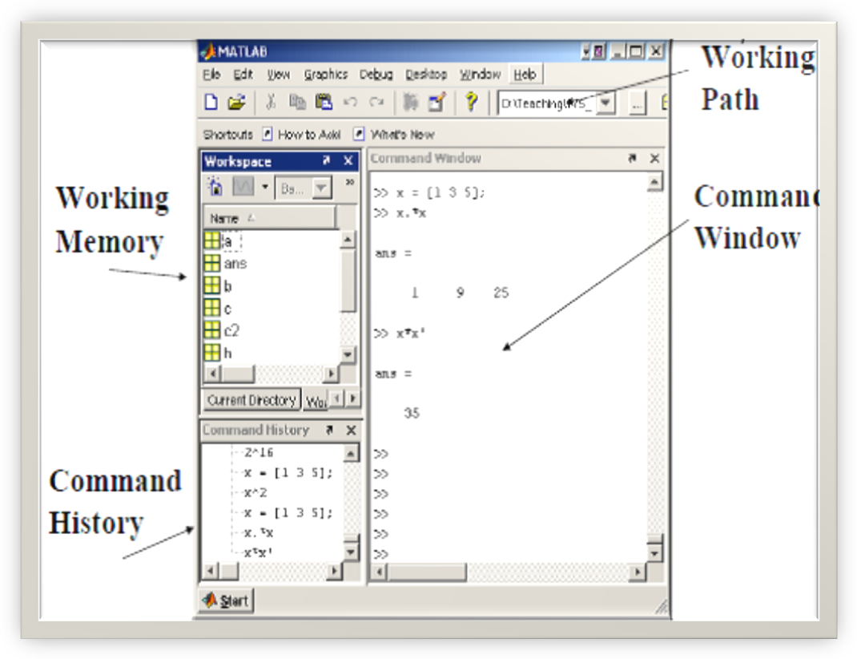

Figure 5.1 Matlab Basic Window

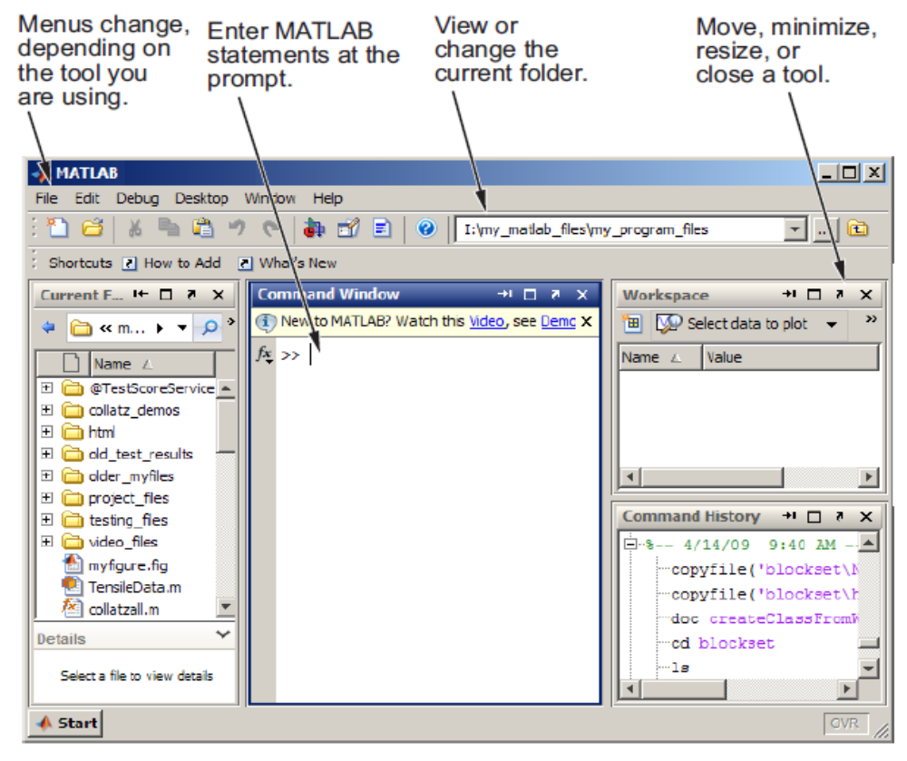

Figure 5.2 Matlab Described Tools Window

5.2 Requirements
5.2.1 Parameter Measured
(1) Error Minimize: Here objective function J_{E}, C_{j} centroid (mean of objects) for cluster j, x_{i} case i, n is number of cases, k number of cluster, distance function.
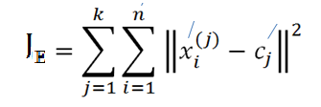
(2) Time Analysis: It is process of dataset analysis time is equal execution time of CPU time.
  - Data Analysis on medical dataset and Find Output

- Yeast dataset Analysis
Yeast dataset analysis finds protein (nucleoprotein) localization prediction in analysis using K-Mean Clustering and proposed method (PGASVM).existing Algorithms time average and error more but our proposed Algorithms minimum time and minimum error.
Table 5.1 Yeast Dataset Analysis

Algorithms | Set Random Values | Time | Error Rate
K-Mean Clustering | 0.888992 | 8.48645 | 4.78042
PGASVM | 0.888992 | 7.37885 | 1.98594

- Yeast Dataset Output Graph
Show result in graph red line represent K-Mean Clustering and green line represent PGASVM (proposed method).Existing Algorithms time average and error more but proposed method minimum time and minimum error. It is provided best result.

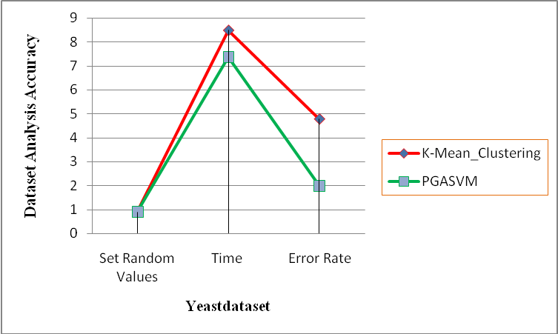

Figure 5.3 Yeast Dataset Base Analysis

- E_coli_dataset Analysis
E_coli_dataset analysis finds protein (nucleoprotein) localization prediction in analysis using K-Mean Clustering and proposed method (PGASVM).existing Algorithms time average and error more but proposed method minimum time and minimum error

Table 5.2 E_coli_dataset Analysis

Algorithms | Set Random Values | Time | Error Rate
K-Mean Clustering | 0.354555 | 3.99363 | 3.88617
PGASVM | 0.354555 | 2.48042 | 1.19223

- E_coli_dataset Output Graph
Show result in graph red line represent K-Mean Clustering and green line represent PGASVM (proposed method).Existing Algorithms time average and error more but proposed method minimum time and minimum error. It is provided best result.

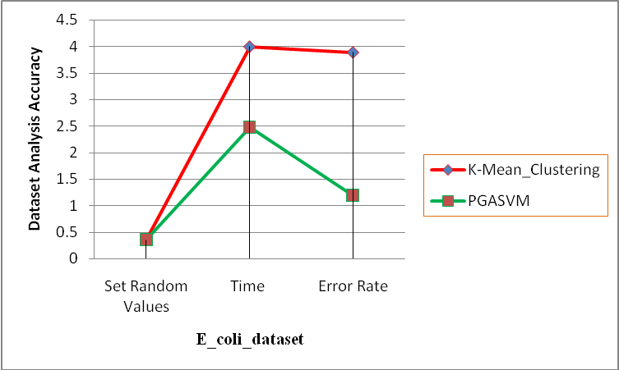

Figure 5.4 E_coli_Dataset Base Analysis

5.4 Output Analysis
Improve accuracy and performance analysis using different dataset based on k-means clustering and GASVM.dataset analysis accuracy. Yeast dataset analysis finds protein (nucleoprotein) localization prediction in analysis using K-Mean Clustering and proposed method (PGASVM).existing Algorithms time average and error more but our proposed Algorithms minimum time and minimum error and E_coli_dataset analysis finds protein (nucleoprotein) localization prediction in analysis using K-Mean Clustering and proposed method (PGASVM).existing Algorithms time average and error more but proposed method minimum time and minimum error. Show result in graph red line represent K-Mean Clustering and green line represent PGASVM (our proposed Algorithms).Existing Algorithms time average and error more but proposed method minimum time and minimum error. It is provided best result.

Chapter 6
Conclusion and Future Work

6.1 Conclusion
Overall the aim of group is to be to determine the central grouping during a set of not labeled information. Information this paper conclude that increasing efficiency of k mean algorithmic rule and Users realize higher results such as queries and execution time additionally reduced. The k-means rule is wide used for cluster massive sets of information. However the quality rule doesn't invariably guarantee smart results because the accuracy and efficiency is cut in spatial arrangement setting. Projected rule notice higher results and increasing potency queries and execution time additionally reduced. Projected rule and existing k-means cluster victimization e_coli dataset and yeast dataset and realize best solution. Find useful information extract in dataset and minimize cluster Increase accuracy and minimize error in Extract reliable data .Minimize error-values in clustering. Existing k-means cluster is more error in yeast dataset and E_coli dataset but over proposed algorithm PGASVM are less error in both dataset and good accuracy.

6.2 Future Work
The algorithm may fail on image dataset. Future job will be focused on medical image dataset and find useful information in medical image. Future work will be enhancing the performance further by applying inherited operative in different sequences and selecting the initial population using statistical parameters find as well.

